    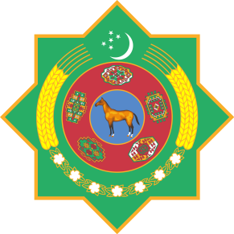

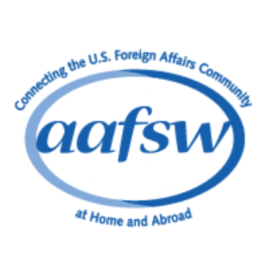

**The Associates of the American Foreign Service Worldwide (AAFSW) in collaboration with the Embassies of**

**Azerbaijan, Kazakhstan, Kyrgyzstan, Tajikistan, Turkmenistan, Türkiye and Uzbekistan**

cordially invite you

…………………………………………………………………………………….

to the joint Nowruz Holiday Reception at the State Department

330 21st Street Entrance of the State Department, Washington. D.C. 20520

Tuesday, March 21, 2023 from 11:00 a.m. to 13:00 p.m.

RSVP by March 17, 2023

through registering: https://www.aafsw.org/event/an-enchanting-journey-to-nowruz-bayram-2/

Business or national attire

Military: service dress

This invitation is not transferable